

Flight Training - Aircraft Maintenance - Flight Support

**DoD SkillBridge Certified Private Pilot and Instrument Rating Training Plan Overview:**

Pilot trainees are trained in local operations including administration of part 61 and part 141 private pilot, instrument pilot, and commercial pilot syllabi; as well as multi-engine, CFI and CFII syllabi. Pilot trainees learn the process of applying FAA regulations in support of local flight operations and procedures to support safe and effective development of qualified civilian pilots. In addition, Pilot trainees become familiar with all aspects of flight school operations including aircraft maintenance, avionics, and flight support as a fixed base of operations (FBO). As one of only two FAA 141 flight schools approved to offer the ATP/CTP course, pilots have the option of attending the course while still serving as interns in flight training programs, a huge advantage equipping graduates with all required tools for a successful airline pilot career. During this program Pilot trainees are under the direct supervision and surveillance of the Chief/Assist Chief of SkyWarrior Inc.

**Goal:**

The FAA defines aeronautical experience by the accumulation of hours of total time as a pilot. This Internship provides the opportunity for Pilot trainees to gain the experience/build hours towards the airline transport pilot certificate minimum requirements.

**Weekly Tasks*:**

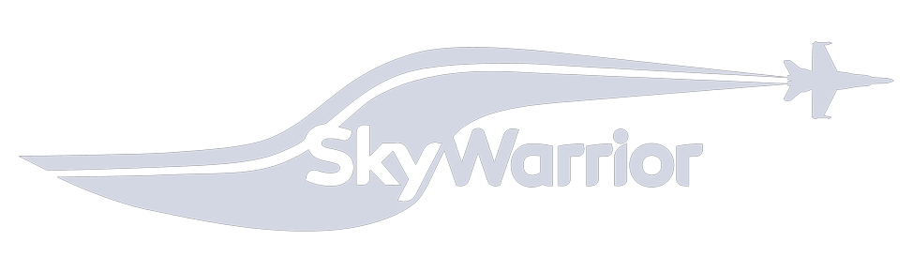Week 1 Pilot orientation, FAA/TSA badging, policy review. Includes required human resource in processing as well as an entrance interview with chief pilot/assistant chief pilot to establish expectations as a Pilot trainee. Review of training programs for the school as required by Title 14 of the Code of Federal Regulations (CFR) part 141, including structured training programs and syllabi. Lastly, flight line credentials

|  |  |
| --- | --- |
|  | IAW TSA regulations for safety and security of the airfield. In the case that military instructors need to convert their military experience into FAA ratings the first week (and possibly two) are allotted to complete this task. |
| Week 2-8 | Private Pilot training.  The Private Pilot Certificate is the initial qualification earned by aviators who are not formally military pilots. The Private Pilot Certificate allows for time building toward a commercial airline pilot career, as well as all of the general pilot knowledge for safe operation of an aircraft. All non-military pilots must start with the FAA Private Pilot Certificate.  Private Pilot Breakdown  Week 1-2: Stage One flight and ground. Basic aviation ground and flight introduction and maneuvers. Tower and ground communications and basic FAA regulations.  Week 3-6: Stage Two flight and ground. Continued flight and ground maneuvers and introduction to cross country navigation and night flight.  Week 6-8: Stage Three flight and ground. Check ride preparation and final lessons and stage checks. FAA written exam completion and IACRA form verification for FAA check ride. |
| Week 8-16 | Instrument Rating.  The Instrument Rating is a follow-on rating to the Private Pilot and is mandatory prior to becoming a flight instructor AND a commercial pilot that carriers passengers. The instrument rating is focused on pilotage in inclement weather and clouds. To become an airline pilot you must have the instrument rating.  Instrument Rating Breakdown  Week 1-2 Stage One flight and ground training. Basic introduction to IFR flying rules and regulations as well as basic flight maneuvers with no visual reference.  Week 3-4 Stage Two flight and ground training. Introduction into airport procedures and approaches including precision and non-precision approaches.  Week 5-6 Stage Three flight and ground training. Introduction into navigation procedures and airways. Cross country and night flying procedures.  Week 7-8 Stage Four flight and ground training. Check ride preparation and final lessons and stage checks. FAA written exam completion and IACRA form verification for FAA check ride. |

Week 16-24 Commercial Pilot

Commercial pilot certificate allows pilot who hold at least a class 2 medical rating fly for hire and carry passengers for hire. Once you hold your commercial pilot certificate you may advanced to certificated flight instructor OR if you are qualified you may apply for the Airline Transport Pilot certificate.

Commercial Certificate Breakdown

Week 1-3: Stage One flight and ground. Introduction to commercial procedures and acting as pilot in command with passengers or crew. Introduction into commercial pilot maneuvers.

Week 4-7: Stage Two flight and ground. Cross country and solo flying and time building both day and night. Introduction into complex and technically advanced aircraft flying

Week 8-9: Stage Three flight and ground. Check ride preparation and final lessons and stage checks. FAA written exam completion and IACRA form verification for FAA check ride.

*Weekly tasks are in no way binding, flow/type of students varies with demand/weather/etc