

Flight Training - Aircraft Maintenance - Flight Support

**DoD SkillBridge Certified Flight Instructor (CFI) Internship Training Plan Overview:**

CFI Interns are trained in local operations including administration of part 61 and part 141 private pilot, instrument pilot, and commercial pilot syllabi; as well as multi-engine, CFI and CFII syllabi. CFI Interns learn the process of applying FAA regulations in support of local flight operations and procedures to support safe and effective development of qualified civilian pilots. In addition, CFI interns become familiar with all aspects of flight school operations including aircraft maintenance, avionics, and flight support as a fixed base of operations (FBO). As one of only two FAA 141 flight schools approved to offer the ATP/CTP course, pilots have the option of attending the course while still serving as interns in flight training programs, a huge advantage equipping graduates with all required tools for a successful airline pilot career. During this program CFI interns are under the direct supervision and surveillance of the Chief/Assist Chief of SkyWarrior Inc.

**Goal:**

The FAA defines aeronautical experience by the accumulation of hours of total time as a pilot. This Internship provides the opportunity for qualified CFIs to gain the experience/build hours towards the airline transport pilot certificate minimum requirements.

**Weekly Tasks*:**

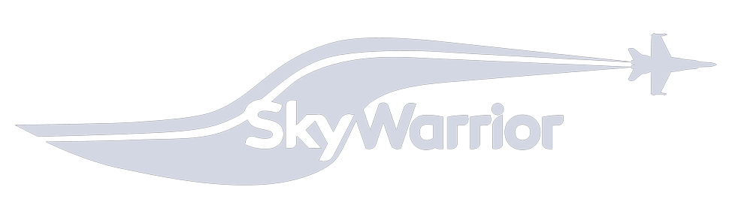Week 1 CFI orientation, FAA/TSA badging, policy review. Includes required human resource in processing as well as an entrance interview with chief pilot/assistant chief pilot to establish expectations as a CFI. Review of training programs for the school as required by Title 14 of the Code of Federal Regulations (CFR) part 141, including structured training programs and syllabi. Lastly, flight line credentials

|  |  |
| --- | --- |
|  | IAW TSA regulations for safety and security of the airfield. In the case that military instructors need to convert their military experience into FAA ratings the first week (and possibly two) are allotted to complete this task. |
| Week 2 | Initial aircraft checkout/signoff/local area procedures. Flight with chief or assistant chief pilot, or designated representative, to establish expectations as a CFI, evaluate capabilities and introduce local area procedures in order to match CFI with students. This includes any required aircraft sign-offs and difference training required. Additionally, the CFI meets with maintenance to review forms, understand write-up process, and become familiar with maintenance team. |
| Week 3 | Flying with students. NLT week 3, the CFI will be flying as an instructor with students under CFR part 61 and CFR part 141. This will include ground training in a classroom setting, conducting flight training, determining student proficiency, and reporting on student progress and development of new teaching methods. CFIs are responsible for training students in subjects such as aircraft |

systems, operating procedures, handling emergencies, problem analysis, aircraft navigation, radio operation and aerodynamics.

|  |  |
| --- | --- |
| Week 4-25 | Continued initial student load. Includes weekly interaction and oversight with chief/assistant chief pilot on assessment/feedback from students, as well as instructor meetings to discuss ongoing issues and focus on continued aviation safety. The CFI will continue to administer flight training IAW FAA Code of Federal Regulations to help students meet the requirements for successful completion of their training programs. |

*Weekly tasks are in no way binding, flow/type of students varies with demand/weather/etc